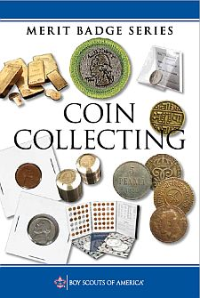
Coin Collecting Merit Badge Workshop
Saturday
April 13, 2019
1:30pm – 5:00 pm

Have fun earning the
Coin Collecting Merit Badge at CoinExpo
Santa Clara Convention Center
5001 Great America Parkway
Santa Clara, CA 95054

Cost: Scouts attending in Class A uniform are not charged admission; Parents/chaperones receive $2 off $6 admission; youth under 12 are free.
Note: Come early to take a look around at the show beforehand which will complete Requirement 10.b.
Get your merit badge pamphlet at the South Bay Scout Shop.

Please email to register for this workshop:
Counselors: Emile Mestressat & Suzy Trigonis
E-mail: coincollectingmb@yahoo.com

Prerequisites:
- Bring a Blue Card signed by your Scoutmaster.
- Read the Coin Collecting Merit Badge pamphlet.
- It is recommended that Scouts bring a Red Book®, if they have one. One can be purchase at the show at the supplies table across from the American Flag on the bourse. There will be some Red Books to look at during the workshop.
- To get sign-off on the Blue Card, each Scout needs to collect and bring the coins required for Requirements 3, 6, 7, & 9 to show the Merit Badge Counselor. Although we will go over the requirements in the workshop, Scouts should be prepared to demonstrate knowledge for Requirements 1, 2, 3, 4, 5, 7, 8, 9, & 10. Numismatic magazines will be available and time allotted for completion of Requirement 5.b.
- Bring a notebook and pen or pencil.
Numismatists and Merit Badge Counselors will be running the workshop.

